To Do list project

1. Navbar   
     
     
     
     
   background image https://img.freepik.com/free-photo/pastel-blue-vignette-concrete-textured-background_53876-102637.jpg?t=st=1718124060~exp=1718127660~hmac=fe8c4024d3561660db6b6f105b592d74d33ee18b5af2185484652d1c6c5c1e5f&w=1060  
   Add buttons for light and dark mode  
     
   

( 2) Basic Description   
  
  
<https://to-do.office.com/tasks/>  
  
  
  
  
  
  
Website description and tasks   


1. Next page Dynamic type in



1. Dynamic add bar   
     
     
   Buttons to update complete delete and get info of the tasks  
     
     
     
     
     
     
     
   Description of tasks   
   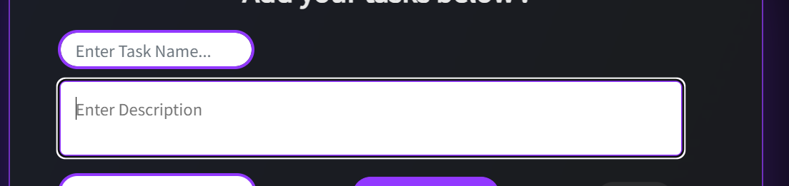  
     
   delete all tasks button  
   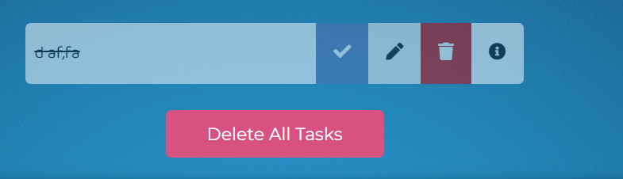  
     
     
     
     
     
     
     
   Search bar to search tasks   
   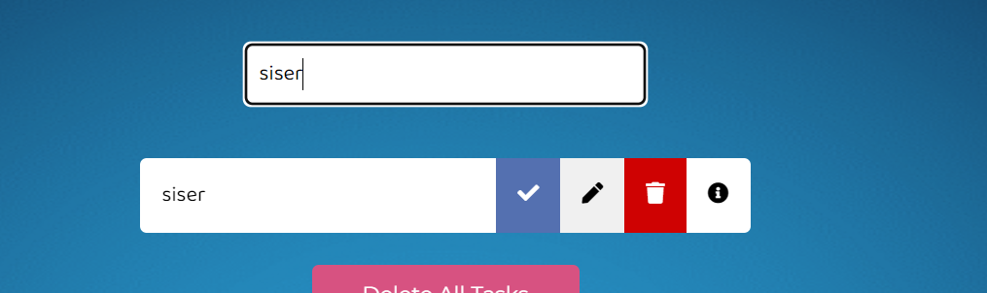

Separate button to add in to check completed, incomplete and all tasks   
Link <https://github.com/avinash201199/To-Do-List?tab=readme-ov-file#website-link->  
Link <https://github.com/tusharnankani/ToDoList>

Count tasks button   
  
  
  
  
  
Footer   
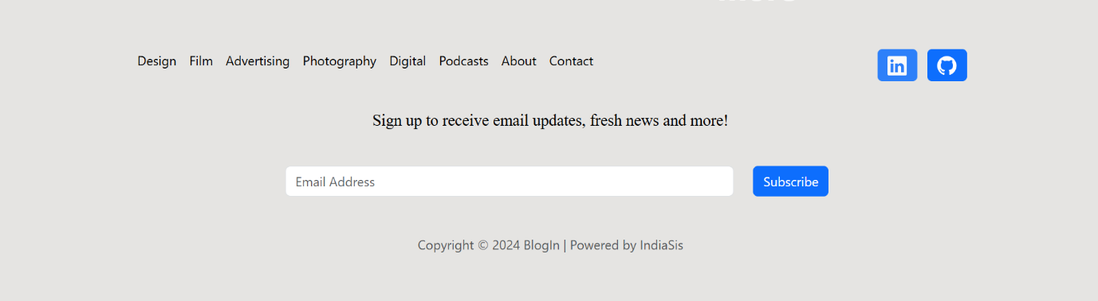

I:\Placement\Web development\_Projects\Blog Website-1\BlogIn\BlogIn

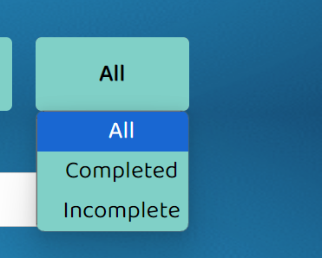

1. Count tasks

1. Separate dropdown to check into type of work   
   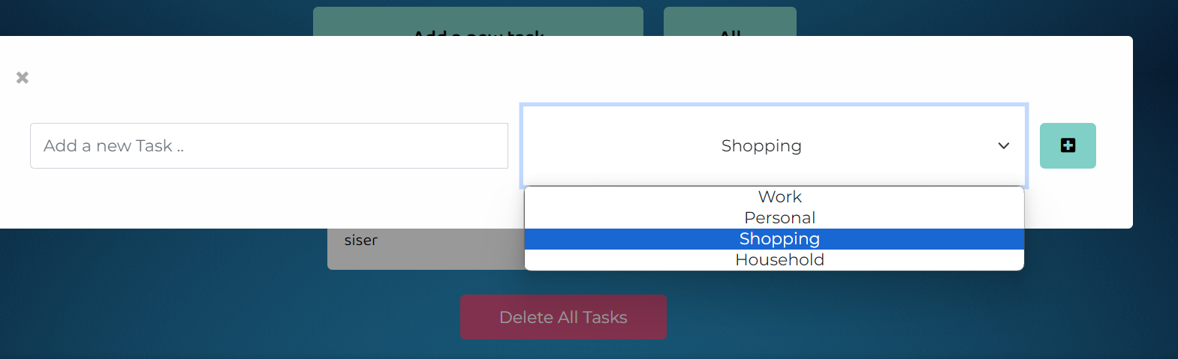

1. Date Dropdown menu   
   